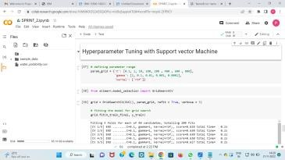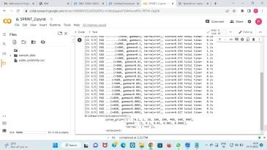Project Development Phase Model Performance Test

|  |  |
| --- | --- |
| Date | 10 NOvember 2022 |
| Team ID | PNT2022TMID38102 |
| Project Name | EFFICIENT WATER QUALITY ANALYSIS  AND PREDICTION |
| Maximum Marks | 10 Marks |

**Model Performance Testing:**

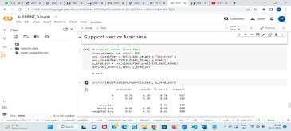Project team shall fill the following information in model performance testing template.

|  |  |  |  |
| --- | --- | --- | --- |
| **S.No.** | **Parameter** | **Values** | **Screenshot** |
| 1. | Metrics | **Support Vector Machine:**  0.6225  **Classification Model:**  Confusion Matrix - , Accuracy Score- & Classification Report –  Precision recall f1-score support  0 0.70 0.69 0.70 497  1 0.50 0.50 0.50 303  accuracy 0.62 800  macro avg 0.60 0.60 0.60 800  weighted avg 0.62 0.62 0.62 800 | 2022-11-21 (7).png |
| 2. | Tune the Model | Hyperparameter Tuning - Validation Method - |  |